**Requirements Review Automation for MVDA Ph-1 and 2**

**Version 1.0**

Process Deployment Assessment / First Draft

**DOCUMENT APPROVAL**

**Meaning of Signatures**:

**Approvers:** Indicates completion of the document review and concurrence with the document content based on the individual team role and area of expertise.

|  |  |
| --- | --- |
| **Approved By:** | <name>, Business Process Owner (BPO) |
| **Approved By:** | <name>, System Owner (SO) |
| **Approved By:** | <name>, Quality System Representative (QSR) |
| **Approved By:** | <name>, Subject Matter Expert (SME) for Technology |
| **Approved By:** | <name>, Subject Matter Expert (SME) for Business Process |
| **Approved By:** | <name>, Validation Lead |

Table of Contents

1. Purpose 6

2. Scope 6

2.1 Purpose/Statement of the Business Problem 6

2.2 In Scope 6

2.3 Out of Scope 6

3. Responsibilities 6

4. Reference Documents 8

5. Glossary 9

6. RPA BOT Process Deployment Strategy and Deliverables 9

7. RPA BOT Inventory 9

8. Risk Management Report 10

9. RPA BOT Overview 10

9.1 Computer System Category 10

9.2 Intended Use and User(s) 10

9.3 Business Process Overview 10

9.4 Current Process Diagram 11

9.5 Applications Used 11

9.6 Inputs and Outputs 11

9.7 Constraints and Limitations 11

9.8 Exceptions 11

9.8.1 Business Exceptions 11

9.8.2 System Exceptions 11

10. Requirements and Specifations 12

10.1 Platform Requirements 12

10.2 User Requirements 12

10.3 Security Requirements 12

10.4 Privacy Requirements 13

11. RPA BOT Design 13

11.1 Physical/Logical Flow (Solution Diagram) 13

11.2 Users (Interactions) 13

11.3 Code Level Controls/Verifications/Validation Checks 13

11.4 Scheduling/Triggers 13

11.5 Module Functions 14

11.6 Code Management 14

11.7 Business Continuity / Disaster Recovery Plan 14

11.7.1 Business Continuity 14

11.7.2 Disaster Recovery & Data Resiliency 14

12. Qualification Strategy 15

13. Test Cases 16

14. Document Management 16

15. Change Management 16

16. Acceptance Criteria 16

17. RPA BOT Description/Trace Matrix 17

17.1 RPA BOT Description 17

17.2 Traceability 18

18. Final Report 18

18.1 Qualification Test Results 19

18.2 Defects Summary 19

18.3 Deviations from the Validation Plan 20

18.4 Conclusion 20

19. Attachments 20

20. Change History 21

## Purpose

This document satisfies Baxter Global Quality Management System (QMS) requirements for software tools per GQP-16-01, Computer System Validation; GITAROS0015, RPA BOT User Procedure; GITAROJ0011, RPA BOT Deployment Guidance; and the Robotic Process Automation (RPA) Platform Validation / Qualification Master Plan, BXU537042.

## Scope

### Purpose/Statement of the Business Problem

Currently SME is working on SIMCA application to build models based on dataset manipulation in excel and getting final output for conducted study

### In Scope

Unattended bot which will perform the following operations

* Process begins by Login to SIMCA Desktop Application
* User will provide the Mean-Centered Master DOE Data and Minion DOE Data
* Next we calculate then Mini DOE Statistics and applying Mini DOE Statistics to Mean-Centered Data
* Build Minion MVDA Models in SIMCA and download Historical Data for Minion Machine
* Evaluate Hotelling’s T2 and DModX Values for Each Model
* Bot execution summary report
* Notify business stakeholders on the execution summary report
* Phase I highlighted in blue on As-Is process flow

Applications involved in the automation are

* MS Excel
* MS Outlook
* SIMCA Application
* Shared Network drive

### Out of Scope

* Input data format – Other than excel sheet
* Validating the downloaded input files
* Phase II highlighted in grey on As-Is process flow
* Resolving performance issues and limitations of excel while processing DOE data
* More than 20 trial combinations or data set with more than 32k records are considered out of scope for this project
* Creation of development environment, test environment, test data for development, and performing user acceptance testing is not considered part of scope​
* Any enhancements to the underlying applications pertaining to automation is not considered part of scope​
* Resolving issues with performance, availability and stability of the applications pertaining to the process automation are considered out of scope​

## Responsibilities

The responsibilities listed are the primary responsibilities for identified roles. The list is not intended to be an all-inclusive list limiting any resource from supporting validation activities as needed. Additional resources or designees may be assigned to validation activities.

The Business Process Owner, System Owner, and QSR are required for RPA BOTs with quality impact. The Validation Lead and SME roles are recommended. The table should be adapted as appropriate.

| Roles / Responsibilities | |
| --- | --- |
| Role | Responsibility |
| Business Process Owner (BPO) | * Accountable that the RPA BOT meets the business requirements. * Accountable to define the user requirements. * Responsible for the business process and the use of the RPA BOT. * Review and approval of applicable validation documentation. * Business process owner may delegate responsibilities to Subject Matter Experts (SME) process. |
| System Owner (SO) | * Ensure that the RPA BOT meets the business requirements. * Accountable to define the functional and design requirements * Accountable for System Management processes * Review and approval of applicable validation documentation. * Owner for implementation and support of technical, security, and operational aspects of the RPA BOT. May delegate responsibilities to Subject Matter Experts (SME). |
| Quality Assurance (QSR) | * QSR responsible for the independent review and approval of applicable IT system GxP requirements and validation deliverables. * Ensure that the RPA BOT deliverables meet requirements. * Ensure that the RPA BOT deliverables meet the business GxP requirements. * Review and approval of validation documentation. |
| Validation Lead (VL) | * Validation Lead (VL) shall be responsible for compiling and maintaining the various validation deliverables, and leading the validation activities throughout the lifecycle. * Prepare and maintain validation assessment during the validation effort. * Coordinate verification activities. * Ensure that the validation and verification activities are performed according to established procedures. * Review and approve test scripts. |
| Subject Matter Experts (SME) | * Subject Matter Experts (SME) shall be involved in the requirements configuration, design and/or testing. * Assist in developing requirement specifications. * Assist in developing code and performing code reviews. * Assist in developing test scripts. * Execute test scripts and assist with defects. * Assist in developing use instructions. * Assist in developing BaxU Training, if necessary. |

## Reference Documents

This section is intended to provide a list of documents referenced throughout this document.

| **Document ID** | **Title** |
| --- | --- |
| GQP-16-01 | Computer system Validation |

## Glossary

In addition to the Baxter’s Glossary the following terms, acronyms, and definitions apply to this document and serve to facilitate understanding:

| Abbreviation, Acronym, or Term | Description/Definition |
| --- | --- |
|  |  |
|  |  |
|  |  |

## RPA BOT Process Deployment Strategy and Deliverables

The overall deployment strategy is to use a single assessment to document the deliverables for pre approval and execution/closure. This will be accomplished by generating two versions of this document.

Document Version No.1 will include the following deliveribles for Pre Approval:

* RPA BOT Inventory
* Plan
* Risk Management Report
* Requirements and Specifications
* Code Management / Code Review
* Qualification Strategy
* Test Cases
* Change Management
* Document Management
* Acceptance Criteria

Document Version No. 2 will include the following deliveribles for Execution/Closure):

* System Description/Trace Matrix
* Test Results and Defect Summary
* Final Report

## RPA BOT Inventory

The unique BOT ID and key attributes will be documented in the RPA BOT Inventory located in the RPA BOT Validation Package PK2005017 per the RPA BOT User Procedure GITAROS0015. . The RPA BOT Inventory will be maintained by the RPA Platform Team.

## Risk Management Report

The <Application Risk Management Report, Document Number> was reviewed to determine the risk of the [RPA BOT Name, Release 1.0]. Based on the System Level Risk Assessment, the RPA BOT is determined to be <Low, Medium or High risk> with qualiy impact per GITSTS0003 and GITRMS0011.

If the RPA BOT is determined to be ‘High Risk’ further Process Risk/Mitigation Assessment is required per GITRMS0011.

## RPA BOT Overview

|  |  |  |
| --- | --- | --- |
| # | Item | Description |
| 1 | **Process full name** | MVDA Phase 1 and 2 |
| 2 | **Process Area** | Digital Transformation |
| 3 | **Department** | MVDA |
| 4 | **Process short description**  (Operation, activity, outcome) | The purpose of this BOT is to automate the MVDA process matching activities |
| 5 | **Role(s) required for performing the process** | User |
| 6 | **Process schedule and frequency** | Adhoc |
| 7 | **# Of items processes /reference period** | 2-3 study / week |
| 8 | **Average handling time per item** | 40 Hours |
| 9 | **Peak period (s)** | NA |
| 10 | **Transaction Volume During Peak period** | 3 study / Day |
| 11 | **Total # of FTEs (Full Time Equivalents) supporting this activity** | 1 |
| 12 | **Expected increase in volume in the next reference period** | Random |
| 13 | **Level of exception rate** | Minimal business and system exceptions |
| 14 | **Input data** | User will send email with Excel attachment which has Study Number and Priority and user will create new folder with study number on Network drive and put four Excel sheets (Detail available in steps description) |
| 15 | **Output data** | 1. Bot will send Exception mail in case of any Business/System Exception 2. Output report (Study#_Analysis.xlsx) will be prepared and placed in output folder in Network Drive and mail notification will be sent to Business stakeholder |

### Computer System Category

MVDA version1.0 is a Category 5 tool.

### Intended Use and User(s)

Automation of MVDA version1.0 is intended to support study and model building exercise from provided study dataset results

### Business Process Overview

|  |  |  |
| --- | --- | --- |
| **S. No** | **Step Action Description** | **Screenshot** |
| 1 | Check for Email from user with Subject as ‘MVDA Input – Date (ddmmyyyy)’ For ex. ‘MVDA Input – 26102022 and with .xlsx attachment  **Business Exception for Bot**:  In case Excel file is not attached in mail attachment  Send exception mail to SME |  |
| 2 | Open Excel sheet and check for Study Number and Priority  In case of multiple Study Number go with the high priority (Ascending) study first  In case if Priority is not mentioned then go with the provided order (Sr. No.) |  |
| 3 | Go to Shared folder path and then in Input folder and check for Study No folder  Note : Consider Study Number before undersquare only |  |
| 4 | Open Study Number folder and Open “**_Master_Centered.xlsx”, “**_Minion_DOE.xlsx”, “Matched DOE_Designs.xlsx” and ‘**_Historical.xlsx’   **Business Exception for Bot**:  In case any input file is missing from above list  Send exception mail to SME |  |
| 5 | Copy all data from “**_Master_Centered.xlsx” sheet 1 and paste it in sheet 1 of New Excel file  Rename sheet 1 of New Excel file to “**_Master_Centered”  Sheet Name should be equal to file name that is provided in Shared folder initially |  |
| 6 | Copy all data from “**_Minion_DOE.xlsx” sheet 1 and paste it in sheet 2 of New .xlsx file  Rename sheet 2 of New Excel file to “**_Minion_DOE”  Sheet Name should be equal to file name that is provided in Shared folder initially |  |
| 7 | Click on File and go to Save As and click |  |
| 8 | Save the file with name Study #_DOEs.xlsx (Ex BXU###_DOEs.xlsx) |  |
| 9 | Create new sheet in Study #_DOEs.xlsx file and rename to ‘VID_Alignment’ |  |
| 10 | Copy first two rows of ‘**_Master_Centered’ from column C (Starts with VID) to end (till available data) and paste it in ‘VID_Alignment’ sheet Column A, Row 1 | ‘**_Master_Centered’    ‘VID_Alignment’ |
| 11 | Copy first two rows of ‘**_Minion_DOE’ from column C (Starts with VID) to end (till available data) and paste it in ‘VID_Alignment’ sheet Column A, Row 3 | ‘**_Minion_DOE’    ‘VID_Alignment’ |
| 12 | Put equation in row 5 and 6 to compare 1,3 and 2,4 rows in ‘VID_Alignment’  Ex. In Row 5 : =IF(A1=A3, "TRUE", "FALSE")  In Row 6 : =IF(A2=A4, "TRUE", "FALSE")  And check the result, It should be ‘True’ in columns of row 5 and 6  **Business Exception for Bot**:  In case if result is not ‘True’  Create new folder inside Output folder of Shared folder path with ‘Study# - Failed – Date Timestamp’ (yyyy_mm_dd_hh_mm_ss) and put working file (Study#_DOEs.xlsx) in to that folder  Send exception mail to SME |  |
| 13 | Create two new sheet in Study#_DOEs.xlsx file and rename to ‘**_Mini_Avg’ and ‘**_Mini_StDev’ |  |
| 14 | Copy all data of first two rows from column C (Starts with VID) to end (till available data) from ‘**_Minion_DOE’ sheet and paste it in Column C row 1 of ‘**_Mini_Avg’ and ‘**_Mini_StDev’ sheets |  |
| 15 | Enter Dataset and Statistics in Row 1 and 2 of Column A and B in both sheets ‘**_Mini_Avg’ and ‘**_Mini_StDev’ |  |
| 16 | Copy Column A (Matched DOE #) data (all data) from ‘Matched DOE Designs.xlsx’ file |  |
| 17 | Paste copied data in Column A (Dataset) and enter ‘Average’ in column B of sheet ‘**_Mini_Avg’ of ‘Study #_DOEs.xlsx’ file |  |
| 18 | Also Paste same copied data in Column A (Dataset) and enter ‘Standard Deviation’ in column B of sheet ‘**_Mini_StDev’ of ‘Study#_DOEs.xlsx’ file |  |
| 19 | Go to sheet ‘**_Mini_Avg’ of ‘Study#_DOEs.xlsx’ file and enter below formula in given cell and replicate same (based on logic) for all data  C3 =AVERAGE(IF(M2_Minion_DOE!$B:$B={1,4},M2_Minion_DOE!C:C))  D3  =AVERAGE(IF(M2_Minion_DOE!$B:$B={1,4},M2_Minion_DOE!D:D))  C4  =AVERAGE(IF(M2_Minion_DOE!$B:$B={2,3},M2_Minion_DOE!C:C))  D4  =AVERAGE(IF(M2_Minion_DOE!$B:$B={2,3},M2_Minion_DOE!D:D)) | Formula in rows of single column is changing based on combination given in ‘Matched DOE Designs’ file. (ex. 1st row - 1,4 2nd row – 2,3 and so on )    Formula in columns of single row is changing based on reference column of ‘**_Minion_DOE’  (ex For C column – ref column is C  For D column – ref column is D)  Replicate formula for all cells for all VID and Dataset |
| 20 | Go to sheet ‘**_Mini_StDev’ of ‘Study#_DOEs.xlsx’ file and enter below formula in given cell and replicate same (based on logic) for all data  For Cell  C3 =STDEV(IF(M2_Minion_DOE!$B:$B={1,4},M2_Minion_DOE!C:C))  D3  =STDEV(IF(M2_Minion_DOE!$B:$B={1,4},M2_Minion_DOE!D:D))  C4  =STDEV(IF(M2_Minion_DOE!$B:$B={2,3},M2_Minion_DOE!C:C))  D4  =STDEV(IF(M2_Minion_DOE!$B:$B={2,3},M2_Minion_DOE!D:D)) | Formula in rows of single column is changing based on combination given in ‘Matched DOE Designs’ file. (ex. 1st row - 1,4 2nd row – 2,3 and so on )    Formula in columns of single row is changing based on reference column of ‘**_Minion_DOE’  (ex For C column – ref column is C  For D column – ref column is D)  Replicate formula for all cells for all VID and Dataset |
| 21 | Create new sheets in ‘Study#_DOEs.xlsx’ file  Here Four sheets created that is based on DOE combinations provided in ‘Matched_DOE_Designs’ file  Sheet name ‘**_Matched_DOE1’, ‘**_Matched_DOE2’ and so on |  |
| 22 | Go to ‘**_Master_Centered’ sheet of ‘Study#_DOEs.xlsx’ file and copy all data from column A and B |  |
| 23 | Paste copied data in all new created sheets of ‘Study#_DOEs.xlsx’ file  Here four sheets i.e ‘**_Matched_DOE1’, ‘**_Matched_DOE2’ and so on |  |
| 24 | Copy rows 1 and 2 from column C to end (Up to last VID) from ‘**_Master_Centered’ sheet of ‘Study #.xlsx’ file |  |
| 25 | Paste copied data in column C in all new created sheets of ‘Study#_DOEs.xlsx’ file  Here four sheets i.e ‘**_Matched_DOE1’, ‘**_Matched_DOE2’ and so on |  |
| 26 | Go to sheet ‘**_Matched_DOE1’ of ‘Study#_DOEs.xlsx’ file and enter below formula in given cell and replicate same (based on logic) and fill all data in sheet  For Cell  C3  =M1_Master_Centered!C3*M2_Mini_StDev!C$3+M2_Mini_Avg!C$3  C4  =M1_Master_Centered!C4*M2_Mini_StDev!C$3+M2_Mini_Avg!C$3  D3  =M1_Master_Centered!D3*M2_Mini_StDev!D$3+M2_Mini_Avg!D$3  D4  =M1_Master_Centered!D4*M2_Mini_StDev!D$3+M2_Mini_Avg!D$3 |  |
| 27 | Go to sheet ‘**_Matched_DOE2’ of ‘Study#_DOEs.xlsx’ file and enter below formula in given cell and replicate same (based on logic) and fill all data in sheet  For Cell  C3  =M1_Master_Centered!C3*M2_Mini_StDev!C$4+M2_Mini_Avg!C$4  C4  =M1_Master_Centered!C4*M2_Mini_StDev!C$4+M2_Mini_Avg!C$4  D3  =M1_Master_Centered!D3*M2_Mini_StDev!D$4+M2_Mini_Avg!D$4  D4  =M1_Master_Centered!D4*M2_Mini_StDev!D$4+M2_Mini_Avg!D$4 |  |
| 28 | For next sheet ‘**_Matched_DOE3’ we need to consider 5th row (C5,D5) from ‘**_Mini_StDev’ and ‘**_Mini_Avg’ sheet for preparing formula  In Same way need to fill all the sheets based on above logic  Here we need to fill details for all four sheets based on Matched DOE combinations (i.e four) |  |
| 29 | Save and close ‘Study#_DOEs.xlsx’ file  Pls note we can’t import this file in SIMCA if it is not closed |  |
| 30 | Go to Start Menu from windows and open SIMCA 16 application |  |
| 31 | Navigate and click on New Regular Project |  |
| 32 | Navigate to ‘Study#_DOEs.xlsx’ file from Shared folder path and click on Open |  |
| 33 | Ensure that ‘Separate sheets’ option is selected and after that keep ‘**_Minion_DOE’ and all Matched_DOE sheets selected  Here ‘**_Matched_DOE1’, ‘**_Matched_DOE2’, ‘**_Matched_DOE3’ and ‘**_Matched_DOE4’ |  |
| 34 | Click on OK and wait it will import all selected sheets in SIMCA |  |
| 35 | Click on first row, select Primary variable ID and click on second row, select Secondary variable ID |  |
| 36 | Go to DATETIME (1st) column, click on Secondary observation ID and go to Trial (2nd) column and click on Secondary observation ID |  |
| 37 | Select all other Columns (Col. 3 to the end) and click on Quantitative and X-variable |  |
| 38 | Repeat above 3 steps (32,33 and 34) for all the sheets in SIMCA |  |
| 39 | After performing all above steps there should be no error at the bottom of sheet |  |
| 40 | Navigate and click on Finish import to finish import  **Business Exception for Bot**:  In case any error occurred it will pop-up on screen  Create new folder inside Output folder of Shared folder path with ‘Study# - Failed – Date Timestamp’ (yyyy_mm_dd_hh_mm_ss) and put working file (Study#_DOEs.xlsx) in to that folder  Send exception mail to SME |  |
| 41 | Save the file as ‘Study # .usp’ (Removing ‘_DOEs’ from excel file name) |  |
| 42 | Go to File and click on Open and than Browse for file which was saved in previous step and Open it |  |
| 43 | Click on Hyperlink to create model or click on New |  |
| 44 | Select ‘**_Monion_DOE’ and click on OK  Also check that should be wizard mode  Note : If it is in Tabbed mode than click on it (same button) to change it to Wizard mode |  |
| 45 | Click on Fit |  |
| 46 | Close chart |  |
| 47 | Double Click on Model M1 which will open new Model window |  |
| 48 | Navigate to Eigenvalue (which is in descending order always) and find nearest Eigenvalue nearest to 1  Click on last row, Click on Add and verify till the time we get the Eigenvalue below 1 (i.e 0.9 etc.) |  |
| 49 | After that remove that last value which was below 1  Using Remove button  Here it is possible that last Eigenvalue is below 1, If it is so than we need to remove values which are below 1 using Remove button until we get last value above 1 |  |
| 50 | Repeat from step 40 to 46  And create models for all the imported Workset one by one |  |
| 51 | Click on button to save |  |
| 52 | Navigate and click on Home, Dataset and than From File |  |
| 53 | Select ‘**_Historical.xlsx’ and click on Open |  |
| 54 | Click on first row and select Primary variable ID |  |
| 55 | Click on second row and select Secondary variable ID |  |
| 56 | Click on first column (DATETIME) and select Primary observation ID |  |
| 57 | Select all other columns and click on Quantitative and X-variable |  |
| 58 | Navigate and Click on Finish import  **Business Exception for Bot**:  In case any error occurred it will pop-up on screen  Create new folder inside Output folder of Shared folder path with ‘Study# - Failed – Date Timestamp’ (yyyy_mm_dd_hh_mm_ss) and put working file (Study#_DOEs.xlsx) in to that folder  Send exception mail to SME |  |
| 59 | Click to close Dataset |  |
| 60 | Navigate and select Model M1 |  |
| 61 | Click on Predict than As dataset and than click on ‘**_Historical’  In case if there are many datasets than need to click on More and after that click on ‘**_Historical’ which will open new window which need to be closed |  |
| 62 | Go to Home and click on Create |  |
| 63 | Select M1 from first drop-down and T2RangePS from second drop-down  From Component (third) drop-down select starting component as 1 and from fourth drop-down select last component (Here it is 5)  and than click on Add series |  |
| 64 | Select M1 from first drop-down and DModXPS from second drop-down  From Component (third) drop-down select last component (Here it is 5)  and than click on Add series |  |
| 65 | Repeat above two steps (60-61) for all models  (Here it is M2,M3,M4 and M5)  and click on OK |  |
| 66 | It will open new window, click on top left and copy all data from dataset and paste in new excel sheet Study#_Analysis.xlsx |  |
| 67 | Create new sheets for each model and segregate data in separate sheets  Here DATETIME column is common for all models and copy other data model wise in E,F and G column  First sheet will be ‘Minion_DOE’ and rest sheets will be ‘Matched1’, ‘Matched2’ and so on (Here up to ‘Matched4’) |  |
| 68 | In SIMCA navigate and select first model M1 from project window |  |
| 69 | Navigate and click on Hotelling’s T2 and DMod |  |
| 70 | From Hotelling’s T2Range and extract value of TrCrit  Here value is T2 = 11.16  Note: We can read this limits using python script also |  |
| 71 | From DModX extract value of M1-DCrit  Here DCrit = 1.314  Note: We can read this limits using python script also |  |
| 72 | In Study#_Analysis.xlsx for model 1 sheet (Minion_DOE) create row and column name as per screenshot and Paste extracted values in Dcrit and T2 columns (i.e B2 and C2 cell)  In third row multiply above values by 1.5 (i.e B2*1.5 and C2*1.5) |  |
| 73 | In Study#_Analysis.xlsx for model 1 sheet (Minion_DOE) create column as  H : Pass/Fail  I : Reject Rate |  |
| 74 | Enter formula  H1 : =IF(G2>$B$3,0,IF(F2>$C$3,0,1))  H2 : =IF(G3>$B$3,0,IF(F3>$C$3,0,1))  Replicate for all data in H column  I1 : =1-AVERAGE(H:H) |  |
| 75 | Select model M2 in SIMCA and repeat from step 65 to step 69 for all models and paste Dcrit and T2 values in each sheets  (Here for sheet for M2 model is ‘Matched1’, for m3 model ‘Matched2’ and so on ) |  |
| 76 | In Study#_Analysis.xlsx for model 2 sheet (‘Matched1’) create column as  H : Pass/Fail  I : Alignment  J : Reject Rate  K : Alignment Rate |  |
| 77 | Enter formula  H1 : =IF(G2>$B$3,0,IF(F2>$C$3,0,1))  H2 : =IF(G3>$B$3,0,IF(F3>$C$3,0,1))  And replicate for all data in H column  I1 : =IF(H2= Minion_DOE!H2,1,0)  I2 : =IF(H3= Minion_DOE!H3,1,0)  And replicate for all data in I column  J1 : =1-AVERAGE(H:H)  K1 : =AVERAGE(I:I) |  |
| 78 | In Study#_Analysis.xlsx for model 3 sheet (‘Matched2’) and repeat step 73 and 74  Perform same for all sheets (Here we have up to ‘Matched4’) |  |
| 79 | Create new sheet ‘Process Matching Matrix’ in Study#_Analysis.xlsx file and create A, B and C column as per screenshot |  |
| 80 | Create column A in ‘Process Matching Matrix’ with model sheet names (i.e Matched1, Matched2 and so on)  Copy values from each model sheet (‘Matched*‘) for Reject Rate and Alignment Rate and paste in ‘Process Matching Matrix’ sheet column B and C |  |
| 81 | Create folder with Study Number – yyyy_mm_dd_hh_mm_ss and save Study#_Analysis.xlsx file, Study#_DOEs.xlsx and Study#.usp file in it also send notification mail to Business stakeholders |  |

### Current Process Diagram

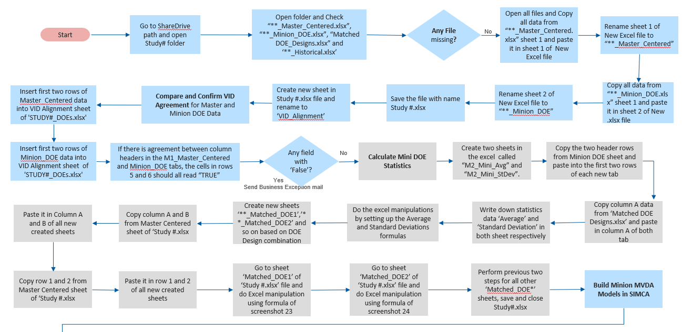

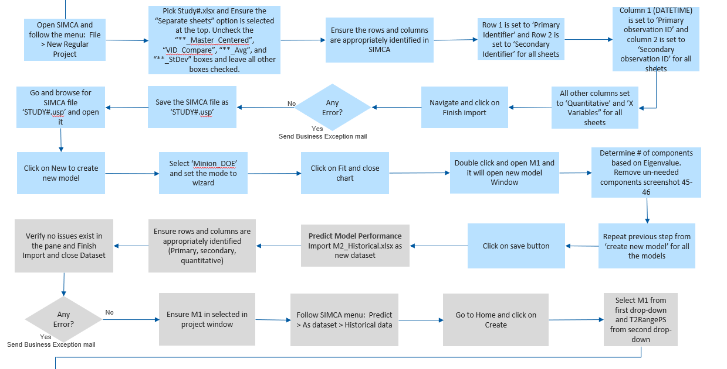

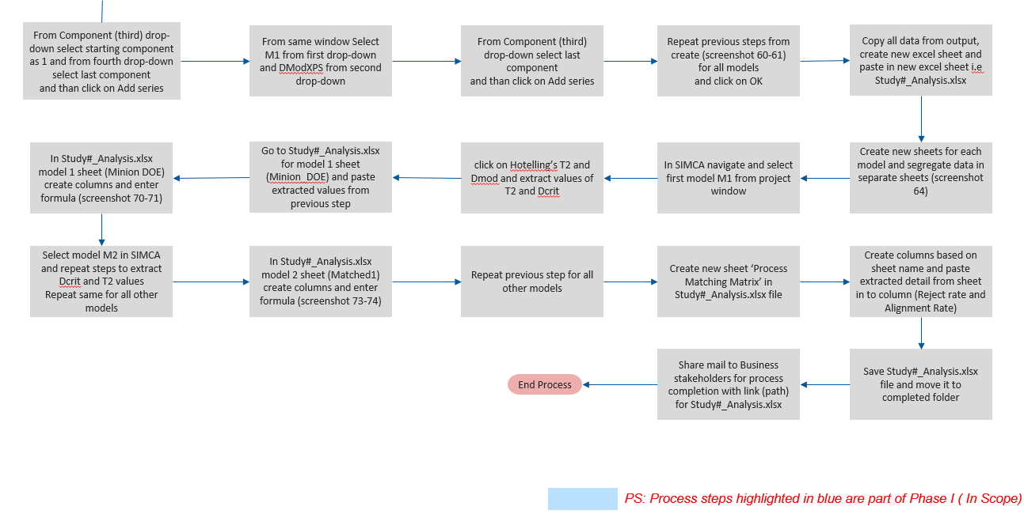

### Applications Used

|  |  |  |  |  |  |
| --- | --- | --- | --- | --- | --- |
| Sr No. | Application name & version | System  Language | Application Type | Environment/  Access method | Comments |
| 1 | SIMCA | EN | Windows Application | Non SSO | Windows application (One time configuration for license is required) |
| 2 | Network Drive | EN |  | SSO | It will be used to store input and output files |
| 3 | Excel | EN | Local Desktop App | -- |  |
| 4 | Outlook | EN | Local Desktop App | SSO | These details will be used to send email alerts from Blue Prism |

### Inputs and Outputs

Input

* Fetching file from Network Drive

Output

* Bot will send Exception mail in case of any Business/System Exception
* Output report (Study#_Analysis.xlsx) will be prepared and placed in completed folder in Network Drive and mail notification will be sent to Business stakeholder

### Constraints and Limitations

| **Type** | **Description** |
| --- | --- |
| *Process Availability* | *Bot can run 24/7* |
| *Application Availability* | *SIMCA availability 24/7* |

### Exceptions

### Business Exceptions

| **Sr No.** | **Business Exceptions** | **Bot action** | **Business team action to be taken** |
| --- | --- | --- | --- |
| 1 | Validate if Excel file is unavailable in mail attachment (Step 1) | Bot must send an email to business stakeholder | Business stakeholders need to take corrective action | |
| 2 | Validate if any input file is missing (Step 4) | Bot must send an email to business stakeholder | Business stakeholders need to process manually or do correction |
| 3 | Validate if any mismatch in VID alignment data (Step 12) | Bot must send email to business stakeholder if data is not ‘True’ after comparison | Business stakeholders need to check |
| 4 | Validate if any pop-up/error message appeared while Finish import (Step 40) | Bot must send email to business stakeholder | Business stakeholders need to process manually |
| 5 | Validate if any pop-up/error message appeared while Finish import (Step 58) | Bot must send email to business stakeholder | Business stakeholders need to process manually |

### System Exceptions

|  |  |  |  |
| --- | --- | --- | --- |
| **Sr No.** | **Technical Exceptions** | **Bot action** | **Business team action to be taken** |
| 1 | Network Drive access failure | * Bot to suspend the process * Notify business stakeholder of the issue | * Fix the login issue and trigger the Bot * Suspend schedules till the issue is addressed |
| 2 | Unable to launch SIMCA application | * Bot to suspend the process * Notify business stakeholder of the issue | * Fix the login issue and trigger the Bot * Suspend schedules till the issue is addressed * Execute fallback plan if any |
| 3 | Unhandled exception | * When same error comes consecutively for 3 times, Bot to notify business stakeholder and stop the process execution * For intermittent unhandled exceptions, Bot to mark the case to be failed in transaction log and proceed with next case | * Review and fix the issue * Reschedule the Bot for execution * Process the failed cases manually or place them back to the report for Bot to pick up in its next schedule |
| 4 | Unable to open File | * Bot to suspend process and share mail | * Check file type and fix issue |

**Unknown Exceptions**

For all the other unanticipated or unknown application exceptions/errors, the robot would send an email notification to respective stakeholders with error message screenshot attached.

## Requirements and Specifications

This section provides a summary of User Requirements and Security Requirements for the [RPA BOT Name, Release 1.0] . The requirements are added in HP Micro Focus under **Domain**: <Domain Name>, **Project**: <Project Name>, **Folde**r: <Folder Name>, **Sub Folder**: <RITMxxxxx> and/or are summarized in the table below:

### Platform Requirements

See RPA Platform System Specification, BXU537041.

### User Requirements

| **Requirement Name** | **Requirement Description** |
| --- | --- |
| URS_001 | <Add requirement> |

### Security Requirements

| **Requirement Name** | **Requirement Description** | **Level of Impact** |
| --- | --- | --- |
| SR_001 | Service accounts are intended to execute processes on behalf of an operating system or application. (e.g. MS-Windows “SYSTEM” account, Apache APACHE_RUN_USER account, etc.) | Platform |
| SR_002 | Service accounts are not intended to allow interactive logins by human beings. | Platform |
| SR_003 | Shared accounts (including service accounts) with interactive use are not allowed. | Platform |
| SR_004 | Service accounts created to provide communications between application components hosted across multi-tier system infrastructures must authenticate to the appropriate server, operating system and/or database. | Application/BOT |
| SR_005 | Service Accounts created to provide access to the application or database must be secured, managed, and not used for interactive use by application users. | Application/BOT |
| SR_006 | Hardcoded password and secrets in scripts and applications should be eliminated (e.g. automating the retrieval of credentials externally from credential vault or other source). | Platform |
| SR_007 | Vendor Accounts provided by and/or considered part of the application/system must not be used to support day-to-day activities. They must be used/accessed on as-needed basis. | Platform |
| SR_008 | Vendor supplied guest accounts must not be used and must be removed or disabled. | Platform |
| SR_009 | BOT id should be authenticated against the system it is accessing OR a service account should be used | Application/BOT |
| SR_010 | Account management security log entries must include the following information: •  The date and time the action was performed | Application/BOT |
| SR_011 | System level security log entries must include the following information: • The date and time the action was performed | Platform |
| SR_012 | BOT development environments must be segregated from production environments. | Platform |
| SR_013 | Blue Prism Login Agent provides a mechanism where by the credentials used by robots are 100% confidential. | Platform |
| SR_014 | BOT security controls should be commensurate with the Application security controls for the tasks or workflow. | Application/BOT |
| SR_015 | BOT folders and fileshares must be restricted to intended Recipients only | Application/BOT |

### Privacy Requirements

This section describes the privacy requirements if any. Corresponding testcases to be completed as part of verification.

## RPA BOT Design

### Physical/Logical Flow (Solution Diagram)

The entire MVDA solution is divided into two sub processes

* Loader Process
* Main Process

**Loader Process:**



**Main Process:**



### Users (Interactions)

This section describes the user interaction scenarios

### Code Level Controls/Verifications/Validation Checks

This section describes the Code Level Controls, Verifications and Code level validation checks required.

### Scheduling/Triggers

Each working day, the Bot will be scheduled at 7 PM (after working hours).

### Module Functions

This section list the different modules designed for the BOT execution.

|  |  |
| --- | --- |
| Process(Main and Subpages) | Description |
| <list all module wise> |  |
|  |  |
|  |  |
|  |  |
|  |  |
|  |  |
|  |  |
|  |  |

### Code Management

This section describes the code files, description, and the bitbucket location. Code is reviewed and managed as defined in GITQAS0017.

|  |  |  |
| --- | --- | --- |
| File Name | Description | Bitbucket Location |
| <Exported File Name/release file> | <short description of file> | <location of code in bitbucket> |

### Business Continuity / Disaster Recovery Plan

This section describes the business continuity, disaster recovery and data resiliency to be performed if the BOT fails.

### Business Continuity

The RPO and RTO values as defined in Application Business Impact assessment (BIA# XXXX).

Contigency plan for the automated BOT to be included here.

### Disaster Recovery & Data Resiliency

The RPA Platform high availability, redundancy and backup of config files will be managed at platform level as described in RPA Platform System Specification (BXU537041).

The RPA Platform doesn’t store BOT level data. Data resiliency is managed at application level as per the application requirements.

## Qualification Strategy

This section provides a summary of the qualification strategy. The qualification will provide evidence the system is installed in accordance with specifications, consistently operates, and performs as intended. HP Micro Focus can be leveraged as the Test Management tool.. For quality impacting RPA BOTS, all IQ and OQ testing will be managed and approved using HP Micro Focus. Testing of the RPA BOT should be commensurate with the complexity and risk of the application task or workflow.

| Deliverable | Ref # | Approval |
| --- | --- | --- |
| IQ and OQ Test Cases | HP Micro Focus under **Domain**: <Domain Name>, **Project**: <Project Name>, **Folde**r: <Folder Name>, **Sub Folder**: <RITMxxxxx> | Installation Qualification (IQ) and Operational Qualification (OQ) testing in the Quality environment will demonstrate the system is developed per the User, Design, Security requirements and will document the BOT meets its intended use.  **Approvals:**   * See RPA BOT User Procedure, GITAROS0015   **Procedure**: GITQAS0021, GITQAS0022 |
| Defects | Defects document any results that do not match the expected results of a test, or any identified issue related to the functionality of the system.  **Approvals:**   * See RPA BOT User Procedure, GITAROS0015   **Procedure:** GITQAS0021, GITQAS0022 |

## Test Cases

This section provides a summary of test cases to be executed. Test cases are added in HP Micro Focus under **Domain**: <Domain Name>, **Project**: <Project Name>, **Folde**r: <Folder Name>, **Sub Folder**: <RITMxxxxx>.

|  |  |
| --- | --- |
| **Test ID** | **Test Case Name** |
| <Test ID> | BOT Installation Qualification Test Case |
| <Test ID> | BOT Security Requirements Verification Checklist |
| <Test ID> | <Test Case Name> |

## 

## Document Management

All documents produced or updated as a result of this validation shall have a unique identity, be version controlled, and reviewed and approved by persons with proper knowledge prior to release for use, utilizing the Team Center Unified (TcU) application, following Global IT Document Change Management, GITQAS0019.

## Change Management

This system will be placed under change management as defined in Global IT Change Management procedure, GITSDS0003 prior to QA execution.

## Acceptance Criteria

The acceptance criteria for the **Qualification Phase Closure** are:

* Process Deployment Assessment Template completed for automation
* Change control created and approved
* All qualification activities and deliverables have been completed and/or approved.
* Test Scripts are executed, reviewed and approved.
* All testing related defects have been logged, resolved and closed or dispositioned with mitigation(s), risk(s) and rationale documented.
* Any deviations identified have been mitigated and documented in the Validation Report(s), as applicable.
* Any exceptions from this plan are documented with risk rationale or acceptance and justification for that acceptance in the Final Reports.

## RPA BOT Description/Trace Matrix

### RPA BOT Description

The purpose of this System Description is to define and summarize supporting quality documentation.

|  |  |
| --- | --- |
| SYSTEM NAME: | <System Name> |
| SYSTEM INVENTORY NUMBER | *<Application ARCHER APP_ID> |
| BOT NAME: | <RPA BOT Name> |
| UNIQUE BOT ID | <RPA BOT ID> |
| BOT DESCRIPTION: | <RPA BOT Description> |
| BOT CATEGORY: | Category 5 |
| OVERALL RISK RATING: | <Quality System Risk Level> |
| CHANGE MANAGEMENT PROCEDURE: | GITSDS0003 |
| PROBLEM REPORTING PROCEDURE: | GITQAS0016 |
| SYSTEM USER PROCEDURE | <Document Number> |
| OPERATIONS MANUAL | <Document Number>, if BOT supports Operational activities. |

*Note: Enter the Application Archer ID where RPA BOT is being deployed.

### Traceability

This section provides a summary of traceability of requirement to test cases. Requirements are detailed in section 9.0 of this document. Test cases are detailed in section 11 of this document. The table below provides a link of change control, user requirements and location of operational test cases in HP Micro Focus.

| **Change Control** | **User Requirements** | **Installation Qualification Test Cases** | **Operation Qualification Test Cases** |
| --- | --- | --- | --- |
| <RITMxxxxx> | HP Micro Focus under **Domain**: <Domain Name>, **Project**: <Project Name>, **Folde**r: <Folder Name>, **Sub Folder**: <RITMxxxxx> | HP Micro Focus under **Domain**: <Domain Name>, **Project**: <Project Name>, **Folde**r: <Folder Name>, **Sub Folder**: <RITMxxxxx> | HP Micro Focus under **Domain**: <Domain Name>, **Project**: <Project Name>, **Folde**r: <Folder Name>, **Sub Folder**: <RITMxxxxx> |

The Traceability Matrix is created, managed and maintained in the Baxter Healthcare Corporation (Baxter) HP Micro Focus system. This system enforces requirements to be mapped to test cases. The acceptance status of testing and the requirements coverage status are generated from the user and/or functional requirement. Advantages for maintaining the Traceability Matrix in HP Micro Focus include real time status of requirements traceability, mapping of ongoing testing necessitated under change control or new project initiatives and real-time reporting of requirements traceability and testing status.

## Final Report

This Final Report provides an overview of the results of the <RPA BOT Name, Release 1.0>validation including the results of testing. The *Computer System Validation*, GQP-16-01, is the guiding procedure for the creation of this Final Report.

The acceptance criteria, as defined in Section 14 of this document, established the requirements to be met prior to the closure of the validation activities. As detailed in section 7 of this document, the validation activities met the acceptance criteria established and have been successfully completed.

Therefore, it is the decision of the stakeholders shown as approvers of this document to close the Validation activities. The <RPA BOT Name, Release 1.0>meets its intended use and is fit to be in production use. The <RPA BOT Name, Release 1.0>is released for operational use.

### Qualification Test Results

This section summarizes the IQ and OQ Testing performed. See Attachment 3 for Test Results

| ***Execution Status*** | ***Number of Tests*** |
| --- | --- |
| Passed | 0 |
| Passed with Incident | 0 |
| Failed | 0 |
| Not performed | 0 |

### 

### Defects Summary

This section summarizes the defects that were found during testing. See Attachment 4 for Defects Summary, if applicable.

| **Classification** | **Defects per Category** | **Defect Status** | **Total per Status** |
| --- | --- | --- | --- |
| High | 0 | Open | - |
| Resolved | - |
| Closed | - |
|  |  |  |  |
| Medium | 0 | Open | - |
| Resolved | - |
| Closed | - |
|  |  |  |  |
| Low | 0 | Open | - |
| Resolved | - |
| Closed | - |

### Deviations from the Validation Plan

This section provides summary of deviations from the validation plan. There were no deviations from the validation plan.

### Conclusion

This section will be provides summary of approval of this report and provides authorization to release <RPA BOT Name, Release 1.0>for use and all activities listed are completed. Thus, <RPA BOT Name, Release 1.0>is deemed validated for its intended use.

## Attachments

The following documents are appended to this document:

|  |  |
| --- | --- |
| **Attachment** | **Description** |
| Attachment 1 | ‘**_Master_Centered.xlsx’ (User input) |
| Attachment 2 | ‘**_Historical.xlsx’ (User input) |
| Attachment 3 | ‘**Matched DOE Designs.xlsx’ (User input) |
| Attachment 4 | ‘**_Minion_DOE.xlsx’ (User input) |
| Attachment 5 | ‘Study#_DOEs.xlsx’ (to be created by Bot) |
| Attachment 6 | ‘Study#_Analysis.xlsx (to be created by Bot) |
| Attachment 7 | BusinessException.txt |
| Attachment 8 | Input Email Template |
| Attachment 9 | Completion Email template(with attached summary report) |





## Change History

|  |  |  |
| --- | --- | --- |
| **Rev** | **Description of Change** | **Issue / Effective Date** |
| 1 | Initial document creation. Changes were implemented per RITMxxxxx. | See Stamp |